# Automated SharePoint 2013 deployment on AWS

The goal of this blog post is to walk you through a script for deploying SharePoint 2013 Farm on [AWS](http://aws.amazon.com/) in an automated manner using PowerShell scripts.

We will be using the following images from AWS gallery

* Image - **ami-2c82e345** (Windows Server 2012 Base)
* Image - **ami-2882e341** (Windows Server 2012 with SQL Server Standard)

[All of the sample code discussed in this article is available here.](http://www.github.com/) (Please note that this is a sample script, provided as-is without any warranties.)

**NOTE:**

1. Download the SharePoint 2013 image from [Microsoft downloads](http://technet.microsoft.com/en-in/evalcenter/hh973397.aspx) and upload the image.
2. Update the Config.xml with the SharePoint key received after the download.

Change the below lines in the xml file.

*<! -- SharePoint Server 2010 Enterprise Product Key (Trial) -->   
<PIDKEY Value=” [Your Key Value]” />*

1. Upload the modified Config.xml and script files StartUp.ps1, ADDSForest.ps1, and to Amazon S3 storage and modify the URLs in script (in workflow AWS-SP-Farm)

The script will use Windows Server 2012 base image for Installation of SharePoint 2013. As default SharePoint VM is not available.

We are going to assume the following SharePoint topology (although you can modify the scripts based on your needs):

* Windows Server 2012 base image hosted on a medium VM instance, serving as the Active directory machine.
* Windows Server 2012 with SQL Server 2012 Standard image hosted on a medium VM instance, serving as the database server.
* Two Windows Server 2012 base images hosted on a medium VM instance, serving as SharePoint Web Front Ends.

We decided to leverage PowerShell workflow, and as a result you need to have PowerShell version 3 installed to run the script.

We choose to use workflow for the following reasons:

* Ability to resume a workflow from a previous state using checkpoints. ([More information here.](http://technet.microsoft.com/en-us/library/jj574114.aspx))
* Ability to extend the script to run tasks in parallel.

Steps to execute the script are listed below:

1. Download and install the latest [AWS PowerShell tools](http://aws.amazon.com/powershell/).
2. Enable delegation of credentials on the local machine where this script will run.
   1. Enable-PSRemoting -Force
   2. Enable-WSManCredSSP -Role Client –DelegateComputer *.amazonaws.com –Force
   3. Open **gpedit.msc** and browse to **Computer Configuration** > **Administrative Templates** > **System** > **Credentials Delegation**. Double-click “**Allow delegating fresh credentials with NTLM-only Server Authentication**.”

Enable the setting and add the build server to the server list as *.amazonaws.com Double-click “**Allow delegating fresh credentials**.”

Enable the setting and add the build server to the server list as *.amazonaws.com

1. The scripts deploys the servers on default security group, enable ICMP and TCP for all the ports on the security group, as shown below

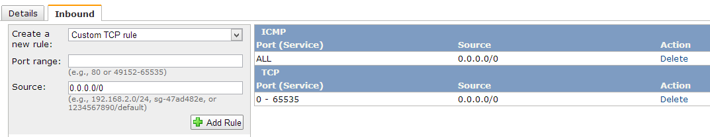

1. Download the script from github repo
2. Change the AWS Access Key, Secret Key and Key Pair Name values in the script ( you will find these settings towards the end of file AWSSPWF.ps1)
3. Execute the script AWSSPWF.ps1.
4. All the VM would be created with password “P@ssw0rd

At a high level, the script is designed to execute the following steps:

1. Create a Windows Server 2012 VM for Active Directory.
2. Create a Windows Server 2012 with SQL Server 2012 Standard VM for Database Server
3. Create two Windows Server 2012 VMs for Installing SharePoint 2013 (later) as Web Front End
4. Retrieve the certificate from the VMs and install it on client computer for executing the commands using WinRM over https.
5. Ping all the Machines to verify they are up and running.
6. Installs Active Directory (in the VM with tag as Domain Controller) and promotes it as the DNS.
7. Adds required service accounts and domain users.
8. Once the above steps are complete, it performs the following tasks in parallel
   1. SQL Server 2012 standard (1 VM)
      1. Join to the Domain.
      2. Add firewall rule to allow access to SQL Server Port.
      3. Change the service accounts of SQL Server to use domain accounts.
      4. Set the max degree of parallelism to 1 for the SQL server.
   2. SharePoint 2013 (2 VMs)
      1. Increase the C drive space to 100 GB (as default 30 GB is not enough to install SP)
      2. Enable SSP (delegation of credentials)
      3. Join to the Domain.
      4. Add domain user (domain\SPFarm) as local system Admin.
      5. Download the SharePoint 2013 setup files
      6. Install the required roles and features
      7. Install SharePoint 2013 Pre-Requisites
      8. Install SharePoint 2013
9. On SharePoint server 1, create a new farm using configuration scripts.
10. On SharePoint server 2, run a script to join the already provisioned farm.
11. Installs remaining services and central administration on SharePoint server 1.

Please feel free to use the scripts, modify it to your needs. Let us know if you need any clarifications we will be happy to help you!